Electrical Overview

Year: 2023 Semester: Spring Team: 18 Project: RDNT

Creation Date: 31 January 2023 Last Modified: 31 January 2023

Author:Avik Wadhwa Email: wadhwa13@purdu.edu

Assignment Evaluation:

| **Item** | **Score (0-5)** | **Weight** | **Points** | **Notes** |
| --- | --- | --- | --- | --- |
| **Assignment-Specific Items** | | | | |
| **Electrical Overview** |  | x3 |  |  |
| **Electrical Considerations** |  | x3 |  |  |
| **Interface Considerations** |  | x3 |  |  |
| **System Block Diagram** |  | x3 |  |  |
| **Writing-Specific Items** | | | | |
| **Spelling and Grammar** |  | x2 |  |  |
| **Formatting and Citations** |  | x1 |  |  |
| **Figures and Graphs** |  | x2 |  |  |
| **Technical Writing Style** |  | x3 |  |  |
| **Total Score** |  | | |  |

5: Excellent 4: Good 3: Acceptable 2: Poor 1: Very Poor 0: Not attempted

General Comments:

*Relevant overall comments about the paper will be included here*

1.0 Electrical Overview

*In your functional specification, your team described the desired/expected functionality of your design. In this section, describe the implementation of that functionality from a hardware perspective. What TYPES of chips, sensors, devices, etc. do you expect to use? (note: these are broad categories, and not specific parts. Don’t provide part numbers here; simply describe the categories of parts (e.g. 16-bit microcontroller, pressure sensor, SD card, etc.) What data is being collected and transmitted by the various devices in your system? What software computations and algorithms are being performed in your design? (e.g. “Our DSP will be used to perform a 16-point FFT while the microcontroller will be used for general computing”) That information should be included here.*

We will use an ESP32 microcontroller.

In order to power our entire device (including LED strips), we will need an AC/DC wall converter from 120V 60Hz to 12V.

We will need a voltage regulator to drop 12V to 5V (for LEDs) and to 3.3V (for microcontroller).

We will use an microphone to receive audio input.

We will use an op-amp to amplify the microphone input.

We will use an op-amp to smoothen the microphone input.

We will use an op-amp to filter noise from the microphone input.

We will use an AUX module to receive audio input.

We will use an RC filter to smoothen the AUX input.

We will use button controls to switch audio input device between microphone and AUX.

The microcontroller will be used for all computing including reading inputs on the ADC, noise reduction on the input, FFT operations, and sending messages to the LED strips.

In terms of data, we will have analog audio signals inputted from AUX-in or microphone that will be read on the ADC. This will be converted into an array values which will be used in the noise reduction program. After noise reduction, the output music values will be fed into the FFT operations. We will also have digital signals from our bluetooth connection, which will act as external controls for the LEDs.

2.0 Electrical Considerations

*This section details design considerations related to the purely electrical aspects of your project. Particular items of interest include:*

* *The operating frequency(ies) used in your system, and justifications for this(these)*
* *A power budget, listing out various system voltages (3.3V, 5V, etc.). For each system voltage, list out major components, the current that these components draw, and the resulting power consumed by each of your components*
* *Tolerances: absolute minimum and maximum voltage/current/power limits for your system*
* *Electrical loading considerations*

Microcontroller operating frequencies: 240MHz

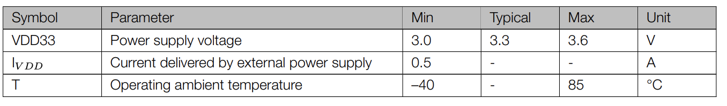

LED strip operating frequencies: 800KHz

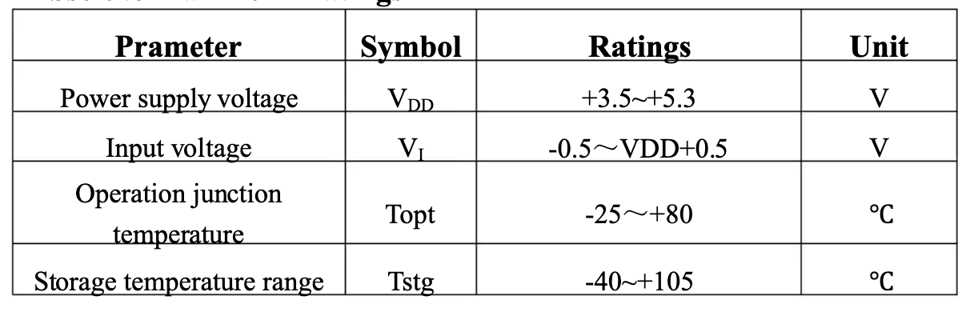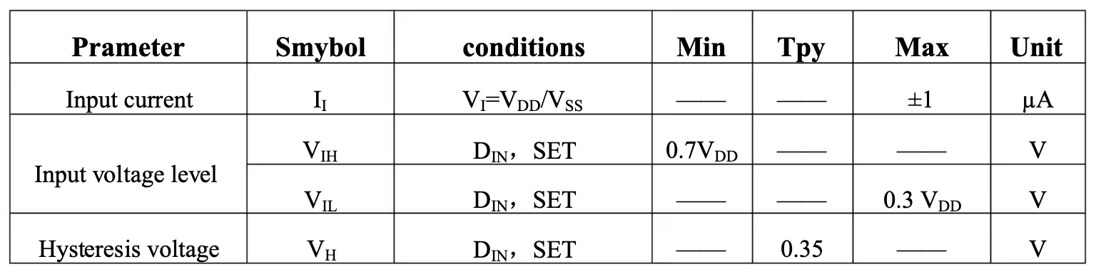

To provide power to our LED strips, we will use a linear voltage regulator to drop 12V to 5V. We will drop this down to 3.3V with our voltage regulator to power our microcontroller and external ADC module. Our microphone, filtering op-amp, smoothing op-amp all also require 3.3V so we will use this same source for them as well.

3.0 Interface Considerations

*This section details the various interfaces utilized in your design (such as USB, UART, I2C, etc.) Relevant information used in this section should include:*

* *Types of interfaces, and their use*
* *Data rates for various system interfaces*

BLE: Input from mobile device (1Mbps data rate)

PWM: Output to LED device

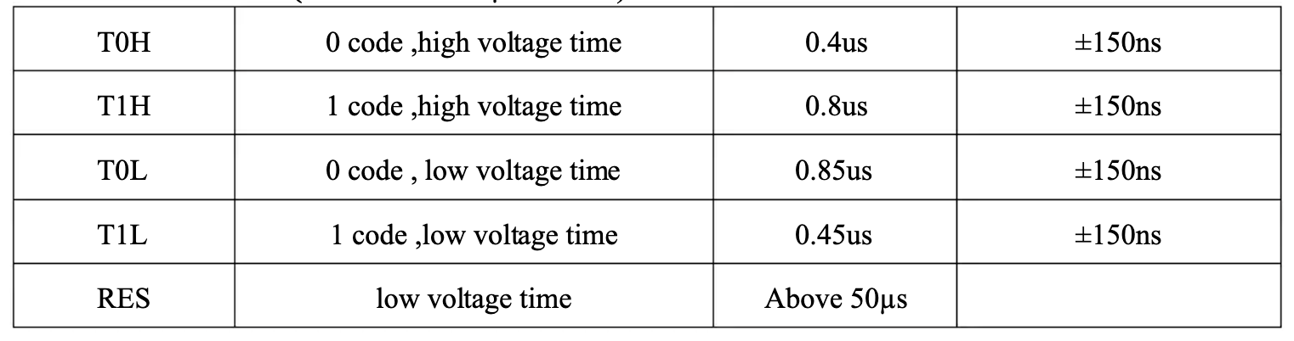

ADC: Input from Microphone and AUX

GPIO: Input mode switching

4.0 Sources Cited:

*Throughout this and other papers, use of the IEEE citation style should be used. Use of embedded hyperlinks for all web-based sources is required. A reference to the IEEE citation style format is provided* [*here*](http://www.ieee.org/documents/ieeecitationref.pdf)*.*

“ESP32-WROOM-32 wi-fi 802.11 & bluetooth module - 4MB FLASH,” *Grid Connect*. [Online]. Available: https://www.gridconnect.com/products/esp32-wroom-32-wi-fi-802-11-bluetooth-module. [Accessed: 04-Feb-2023].

“WS2812B datasheet,” *DigiKey*. [Online]. Available: https://www.digikey.com/en/datasheets/parallaxinc/parallax-inc-28085-ws2812b-rgb-led-datasheet. [Accessed: 04-Feb-2023].

Appendix 1: System Block Diagram

*Include a computer-generated (NOT hand drawn) system block diagram of your design here. Include bus widths and interface types where applicable.*

